**Vector STL**

**Iterators**

1. [begin()](https://www.geeksforgeeks.org/vectorbegin-vectorend-c-stl/) – Returns an iterator pointing to the first element in the vector
2. [end()](https://www.geeksforgeeks.org/vectorbegin-vectorend-c-stl/) – Returns an iterator pointing to the theoretical element that follows the last element in the vector
3. [rbegin()](https://www.geeksforgeeks.org/vector-rbegin-and-rend-function-in-c-stl/) – Returns a reverse iterator pointing to the last element in the vector (reverse beginning). It moves from last to first element
4. [rend()](https://www.geeksforgeeks.org/vector-rbegin-and-rend-function-in-c-stl/) – Returns a reverse iterator pointing to the theoretical element preceding the first element in the vector (considered as reverse end)

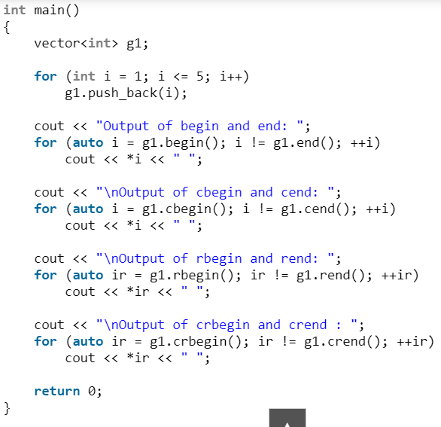

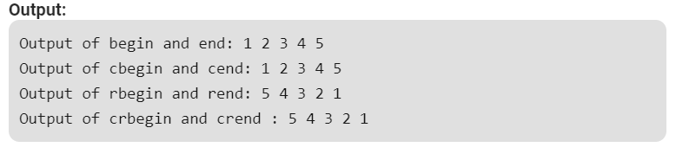

**Capacity**

1. [size()](https://www.geeksforgeeks.org/vectorempty-vectorsize-c-stl/) – Returns the number of elements in the vector.
2. [max_size()](https://www.geeksforgeeks.org/vector-max_size-function-in-c-stl/) – Returns the maximum number of elements that the vector can hold.
3. [capacity()](https://www.geeksforgeeks.org/vector-capacity-function-in-c-stl/) – Returns the size of the storage space currently allocated to the vector expressed as number of elements.
4. [resize(n)](https://www.geeksforgeeks.org/vector-resize-c-stl/) – Resizes the container so that it contains ‘n’ elements.
5. [empty()](https://www.geeksforgeeks.org/vectorempty-vectorsize-c-stl/) – Returns whether the container is empty.
6. [shrink_to_fit()](https://www.geeksforgeeks.org/vector-shrink_to_fit-function-in-c-stl/) – Reduces the capacity of the container to fit its size and destroys all elements beyond the capacity.
7. [reserve()](https://www.geeksforgeeks.org/using-stdvectorreserve-whenever-possible/)– Requests that the vector capacity be at least enough to contain n elements.

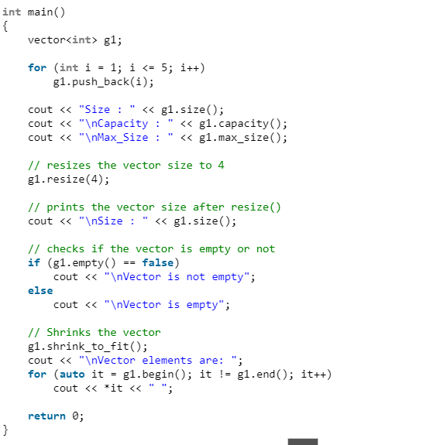

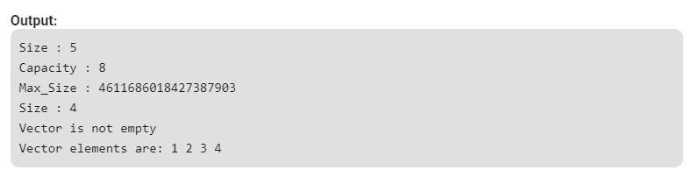

**Element access:**

1. [reference operator [g]](https://www.geeksforgeeks.org/vectoroperator-vectoroperator-c-stl/) – Returns a reference to the element at position ‘g’ in the vector
2. [at(g)](https://www.geeksforgeeks.org/vectorat-vectorswap-c-stl/) – Returns a reference to the element at position ‘g’ in the vector
3. [front()](https://www.geeksforgeeks.org/vectorfront-vectorback-c-stl/) – Returns a reference to the first element in the vector
4. [back()](https://www.geeksforgeeks.org/vectorfront-vectorback-c-stl/) – Returns a reference to the last element in the vector
5. [data()](https://www.geeksforgeeks.org/vector-data-function-in-c-stl/) – Returns a direct pointer to the memory array used internally by the vector to store its owned elements.

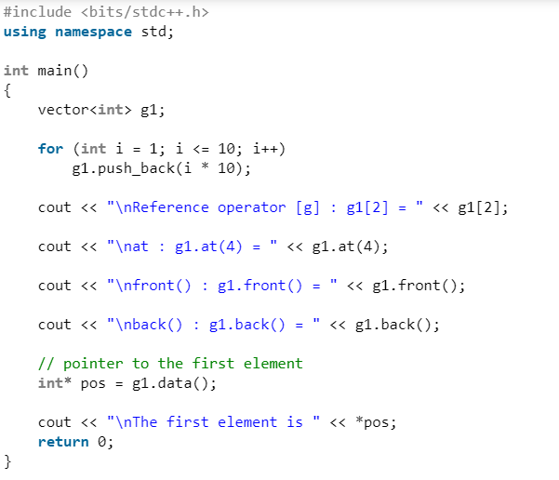

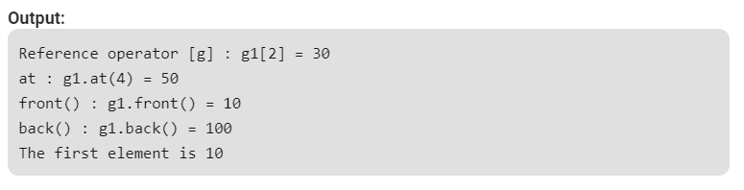

**Modifiers:**

1. [assign()](https://www.geeksforgeeks.org/vector-assign-in-c-stl/)– It assigns new value to the vector elements by replacing old ones
2. [push_back()](https://www.geeksforgeeks.org/vectorpush_back-vectorpop_back-c-stl/) – It push the elements into a vector from the back
3. [pop_back()](https://www.geeksforgeeks.org/vectorpush_back-vectorpop_back-c-stl/) – It is used to pop or remove elements from a vector from the back.
4. [insert()](https://www.geeksforgeeks.org/vector-insert-function-in-c-stl/) – It inserts new elements before the element at the specified position
5. [erase()](https://www.geeksforgeeks.org/vectorclear-vectorerase-c-stl/) – It is used to remove elements from a container from the specified position or range.
6. [swap()](https://www.geeksforgeeks.org/vectorat-vectorswap-c-stl/) – It is used to swap the contents of one vector with another vector of same type. Sizes may differ.
7. [clear()](https://www.geeksforgeeks.org/vectorclear-vectorerase-c-stl/) – It is used to remove all the elements of the vector container
8. [emplace()](https://www.geeksforgeeks.org/vector-emplace-function-in-c-stl/) – It extends the container by inserting new element at position
9. [emplace_back()](https://www.geeksforgeeks.org/vectoremplace_back-c-stl/) – It is used to insert a new element into the vector container, the new element is added to the end of the vector

